

Lab # 06
Mobile Application Development Fall 2024



Course Instructor: Mr. Qaisar Khan

Lab Instructor | Muhammad Ahmed
Student Name | Muhammad Taha
CMSID | 518133
Department | Computer Science
Semester | 4th

Lesson Set 6

Building Widget Trees and Creating Complex Mobile Applications

Purpose 1. Learn how to build a widget tree for a Flutter application.
- Understand how to manage parent-child widget relationships.
- Explore how to nest widgets to create complex user interfaces.
- Implement best practices for designing maintainable and performant widget trees.
- Gain experience using advanced Flutter widgets such as Stack, ListView, and GridView

Procedure 1. Students should read the Pre-lab Reading assignment before coming to the lab.
- Students should complete the Pre-lab Writing assignment before entering the lab.
- In the lab, students should complete Labs 6.1 through 6.4 in sequence. Your instructor will give further instructions on grading and completing the lab.
- Students should complete the set of lab tasks before the next lab and get them checked by their lab instructor.

Contents | Pre-requisites | Completion Time | Page Number
Pre-lab Reading Assignment | - | 20 min | 3
Pre-lab Writing Assignment | Pre-lab Reading | 10 min | 5
Lab 6
Lab 6.1  Understanding Widgets | Pre-lab reading | 30 min | 4
Lab 6.2  Lab Tasks | Awareness of Programming | - | 6

PRE-LAB READING ASSIGNMENT
Introduction to Widget Trees | In Flutter, everything is a widget, and widgets are the building blocks of a Flutter application's user interface. The arrangement of widgets in a hierarchical structure is known as a widget tree.  Each widget represents part of the UI, and Flutter renders this tree onto the screen. A simple app may have a small widget tree, while a more complex app might have a deeply nested widget tree with multiple parent-child relationships.
Understandi ng Widget Composition | Widgets are either stateless or stateful. A stateless widget doesn’t change its state once built, while a stateful widget can update dynamically based on user interaction or data updates.  A widget tree is composed of parent and child widgets. For example, a Scaffold widget might be the root of the tree with various child widgets, such as AppBar, Text, Button, and more.  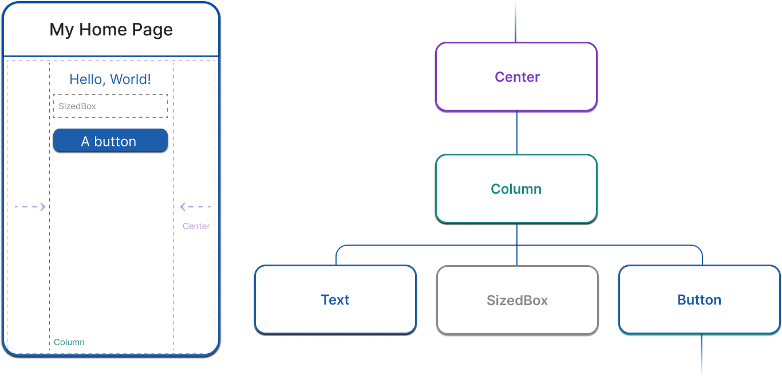
Building Complex User Interfaces | Complex apps are built by creating and nesting widgets within other widgets. Widgets can be combined to create sophisticated UIs. For example, a Column widget can contain several Row widgets, each of which contains Text, Icon, or Button widgets.  As the complexity increases, the widget tree can have several levels of depth, with each level responsible for different parts of the UI.  Best Practices for Building Complex UIs  - Break down complex UIs: Instead of creating a large, monolithic widget tree, break the UI into smaller reusable components.  - Maintain clarity: Ensure the widget tree remains readable by separating logic and UI components. Use functions or separate classes for reusable widgets.

- Performance optimization: Flutter's rebuild mechanism works efficiently, but keeping widget trees manageable and avoiding unnecessary rebuilds helps maintain performance.
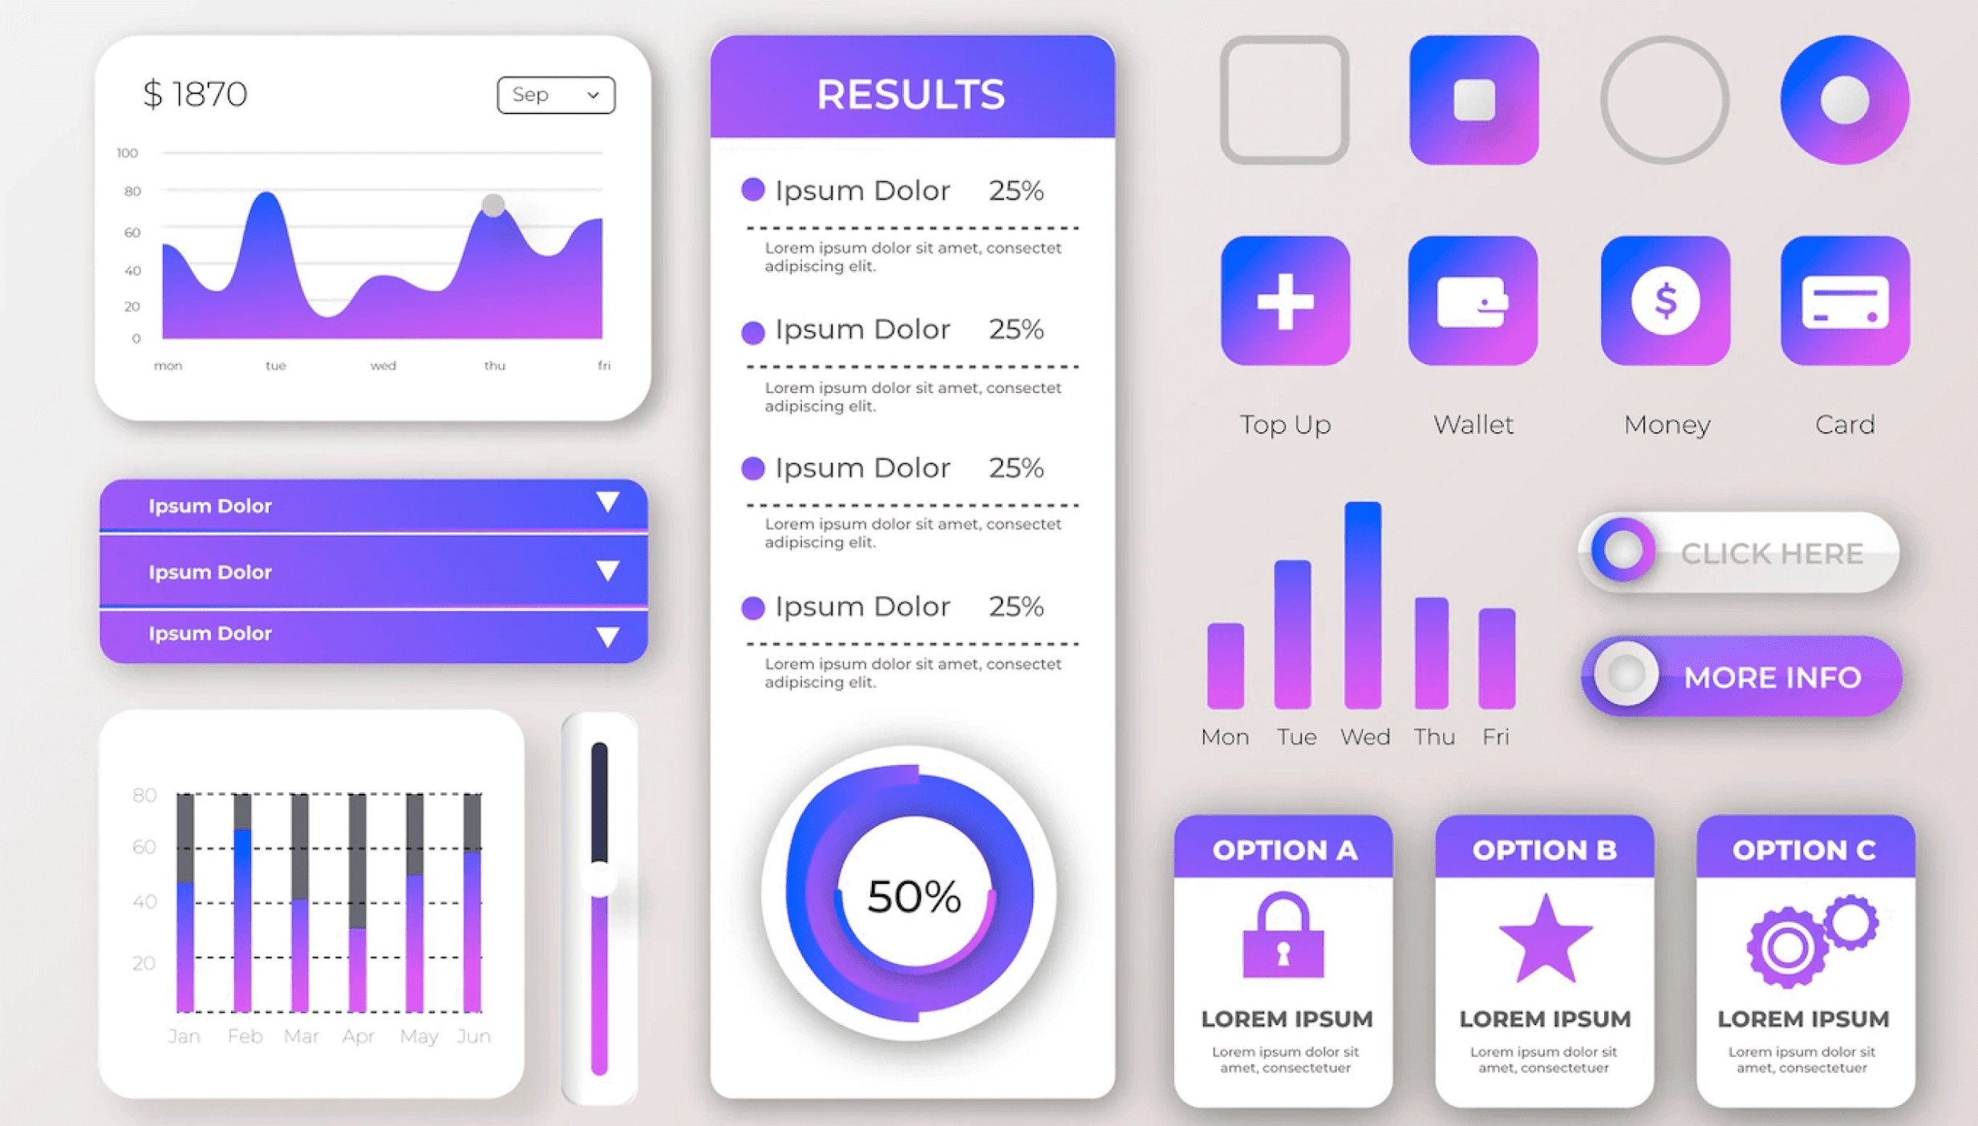
Widget Tree Example
Consider the following simple widget tree:
Scaffold(
appBar: AppBar(title: Text("Complex UI Example")), body: Column(
children: [ Row( children: [
Icon(Icons.star), Text("Rating"),
],
),
Row( children: [
ElevatedButton(onPressed: () {}, child: Text("Press Me")),
],
),
],
),
)

Here, the Scaffold widget is the root of the tree, with an AppBar as its child, and the Column widget inside the body, which contains two rows with child widgets like Icon, Text, and Button.

PRELAB WRITING ASSIGNMENT
Fill in the blanks | - In Flutter, the Scaffold widget is used to define the structure and layout of an application’s visual elements.  - A Stateless widget does not maintain any internal state and is immutable after it's built.  - A Statefull widget allows dynamic updates to the UI based on changes in state.  - The Column widget is commonly used to create a vertical layout of widgets in Flutter, while the Row widget is used for horizontal layouts.  - A ListView widget enables scrolling functionality in a Flutter app, especially  when dealing with a large list of items.

Lab 6.2 | Lab Tasks

TASK 1: Stateful Interactive Counter App with Layout & Popup Menu

Design and develop a Stateful Interactive Counter Application in Flutter.
Your application must demonstrate:
- Proper widget tree structure
- Use of Column and Row for layout
- Multiple ElevatedButtons
- Popup menu options
- State management using StatefulWidget
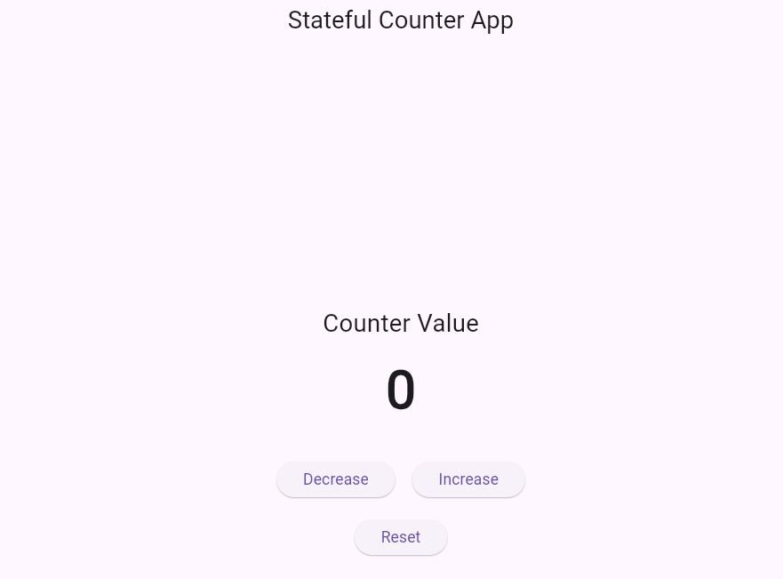
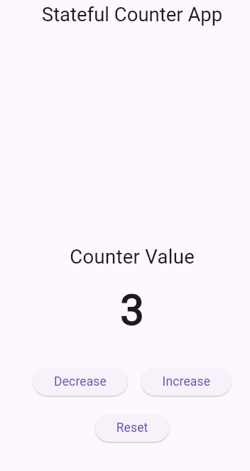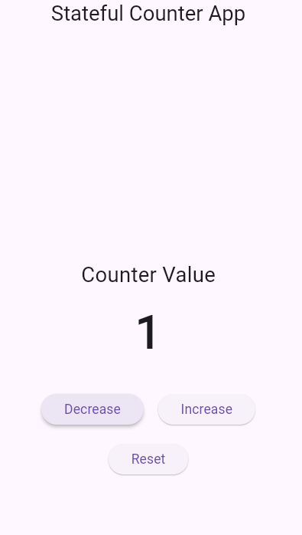
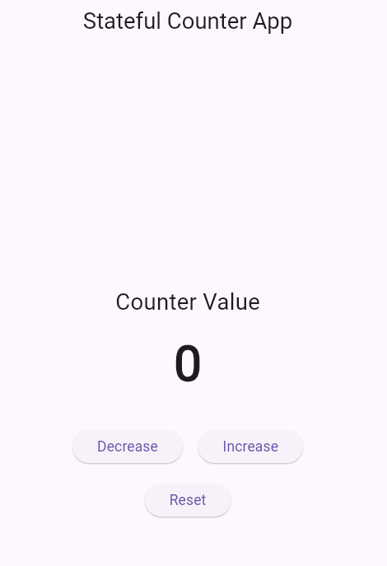
Code For the main.dart file in new_app:
import 'package:flutter/material.dart';

void main() {
runApp(MyApp());
}

// Root Widget (Stateless)
class MyApp extends StatelessWidget {
@override
Widget build(BuildContext context) {
return MaterialApp(
debugShowCheckedModeBanner: false,
home: CounterApp(),
);
}
}

// Stateful Widget
class CounterApp extends StatefulWidget {
@override
_CounterAppState createState() => _CounterAppState();
}

class _CounterAppState extends State<CounterApp> {
int counter = 0;

// Functions to manage state
void increment() {
setState(() {
counter++;
});
}

void decrement() {
setState(() {
counter--;
});
}

void reset() {
setState(() {
counter = 0;
});
}

void showMessage(String message) {
ScaffoldMessenger.of(context).showSnackBar(
SnackBar(content: Text(message)),
);
}

@override
Widget build(BuildContext context) {
return Scaffold(
appBar: AppBar(
title: Text("Stateful Counter App"),
centerTitle: true,
actions: [
PopupMenuButton<String>(
onSelected: (value) {
if (value == "Reset") {
reset();
} else if (value == "About") {
showMessage("Simple Counter App using StatefulWidget");
}
},
itemBuilder: (context) => [
PopupMenuItem(
value: "Reset",
child: Text("Reset Counter"),
),
PopupMenuItem(
value: "About",
child: Text("About App"),
),
],
),
],
),

body: Center(
child: Column(
mainAxisAlignment: MainAxisAlignment.center,
children: [

// Display Text
Text(
"Counter Value",
style: TextStyle(fontSize: 22),
),

SizedBox(height: 10),

Text(
"$counter",
style: TextStyle(
fontSize: 48,
fontWeight: FontWeight.bold,
),
),

SizedBox(height: 30),

// Row Layout for Buttons
Row(
mainAxisAlignment: MainAxisAlignment.center,
children: [

ElevatedButton(
onPressed: decrement,
child: Text("Decrease"),
),

SizedBox(width: 15),

ElevatedButton(
onPressed: increment,
child: Text("Increase"),
),
],
),

SizedBox(height: 20),

// Another Button
ElevatedButton(
onPressed: reset,
child: Text("Reset"),
),
],
),
),
);
}
}

To Receive Credit

- By showing up on time for lab, working on the lab solution, and staying until the end of the class period, only then you can receive full credit for the lab assignment.
- Comment on your program heavily. Intelligent comments and clean, readable formatting of your code account for 20% of your grade.
- The lab time is not intended as free time for working on your programming/other assignments. Only if you have completely solved the lab assignment, including all challenges, and have had your work checked off for completeness by your TA/Lab Engineer should you begin the programming/other assignments.

